**Andmete sisestamine**

insert into dbo.Artist values (NEWID(), 'Lara', 'Mets', '02.02.2000', 'hhgf@hgj.com', '12345678', 1)

insert into dbo.Artist values (NEWID(), 'Markus', 'Leht', '04.04.1999', 'werf@hgj.com', '17284945', 1)

insert into dbo.Artist values (NEWID(), 'Martin', 'Murumäe', '2000.06.12', 'ewft@hgj.com', '27384908', 1)

insert into dbo.Artist values (NEWID(), 'Marek', 'Tamm', '1997.07.18', 'sehf@hgj.com', '37294628', 1)

insert into dbo.Artist values (NEWID(), 'Marius', 'Puu', '2001.08.17', 'ergg@hgj.com', '75937595', 1)

insert into dbo.Artist values (NEWID(), 'Liina', 'Jõhvikas', '2000.09.16', 'fwer@hgj.com', '97867590', 1)

insert into dbo.Artist values (NEWID(), 'Patrick', 'Mari', '1998.10.20', 'wfrt@hgj.com', '102936548', 1)

insert into dbo.Artist values (NEWID(), 'Sara', 'Tool', '1990.11.14', 'sdfe@hgj.com', '86957453', 1)

insert into dbo.Artist values (NEWID(), 'Sten', 'Laud', '1996.12.11', 'tgrg@hgj.com', '73528493', 1)

insert into dbo.Artist values (NEWID(), 'Marten', 'Lammas', '1997.01.10', 'awdr@hgj.com', '65836484', 1)

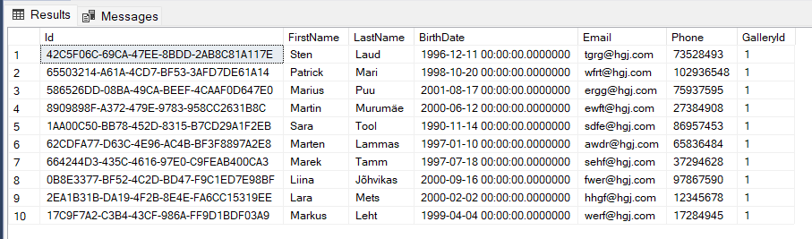

insert into dbo.ArtOwner values (NEWID(), 'Laura', 'Maasik', '12364758', 'gugy@jhf.com', '2000.11.10', 1)

insert into dbo.ArtOwner values (NEWID(), 'Armin', 'Koer', '36473894', 'lcbd@jhf.com', '1996.11.10', 2)

insert into dbo.ArtOwner values (NEWID(), 'Lennart', 'Eesel', '18394528', 'lfor@jhf.com', '1992.11.10', 3)

insert into dbo.ArtOwner values (NEWID(), 'Juss', 'Kaelkirjak', '29374839', 'jfks@jhf.com', '2000.11.10', 4)

insert into dbo.ArtOwner values (NEWID(), 'Rita', 'Kaamel', '26374890', 'brhs@jhf.com', '1997.11.10', 5)

insert into dbo.ArtOwner values (NEWID(), 'Ülo', 'Tihane', '47583902', 'lahd@jhf.com', '1990.11.10', 6)

insert into dbo.ArtOwner values (NEWID(), 'Riina', 'Lind', '26384925', 'bdjr@jhf.com', '2000.11.10', 7)

insert into dbo.ArtOwner values (NEWID(), 'Kristofer', 'Lehm', '15273845', 'hfjr@jhf.com', '1994.11.10', 8)

insert into dbo.ArtOwner values (NEWID(), 'Kris', 'Siil', '36473890', 'ewry@jhf.com', '1997.11.10', 9)

insert into dbo.ArtOwner values (NEWID(), 'Karel', 'Sammal', '20394758', 'hgdf@jhf.com', '2000.11.10', 10)

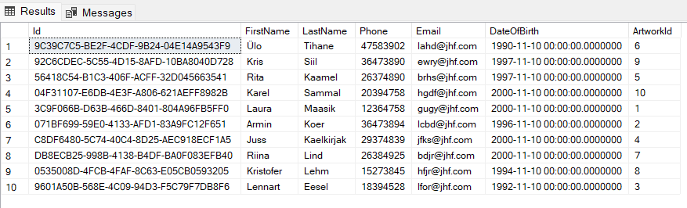

insert into dbo.Artwork values (NEWID(), 'Mets', 100, '2005', 1)

insert into dbo.Artwork values (NEWID(), 'Meri', 1000, '1900', 2)

insert into dbo.Artwork values (NEWID(), 'Järv', 200, '1996', 3)

insert into dbo.Artwork values (NEWID(), 'Linn', 1800, '1990', 4)

insert into dbo.Artwork values (NEWID(), 'Mona Lisa', 400, '2001', 5)

insert into dbo.Artwork values (NEWID(), 'Põõsad', 1500, '1980', 6)

insert into dbo.Artwork values (NEWID(), 'Lagendik', 1200, '1880', 7)

insert into dbo.Artwork values (NEWID(), 'Taevas', 500, '1890', 8)

insert into dbo.Artwork values (NEWID(), 'Kosmos', 1100, '1911', 9)

insert into dbo.Artwork values (NEWID(), 'Maja', 700, '2001', 10)

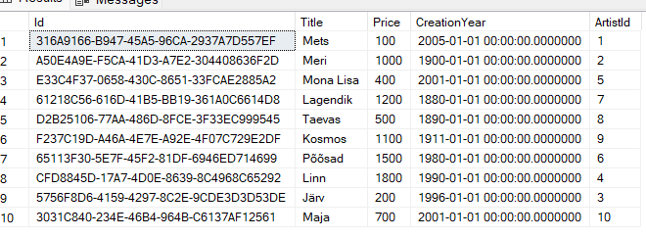

insert into dbo.Categories values (NEWID(), 'Sculpture', 'gdzgsrgzfdgr')

insert into dbo.Categories values (NEWID(), 'Painting', 'aekjnfkiaehif')

insert into dbo.Categories values (NEWID(), 'Painting', 'ewfajuigerf')

insert into dbo.Categories values (NEWID(), 'Sculpture', 'aefbjhagek')

insert into dbo.Categories values (NEWID(), 'Sculpture', 'etrhiuwguyfg')

insert into dbo.Categories values (NEWID(), 'Sculpture', 'wriuuysfb')

insert into dbo.Categories values (NEWID(), 'Painting', 'ewahrguahskvf')

insert into dbo.Categories values (NEWID(), 'Sculpture', 'earygeuwfj')

insert into dbo.Categories values (NEWID(), 'Painting', 'ruiat7alhrfgb')

insert into dbo.Categories values (NEWID(), 'Sculpture', 'sgfwfegdty')

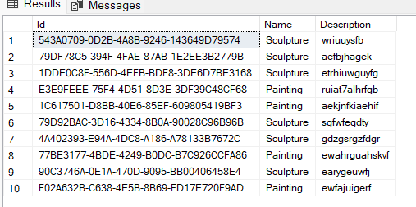

insert into dbo.Gallery values (NEWID(), 'Pintslimaja', 'Metsatuka tee 3', '26359453', '[hfjd@jdh.com](mailto:hfjd@jdh.com)')



(tegin ainult ühe rea andmeid, sest ülesandes oli üks galerii)

**Stored Procedure**

CREATE PROCEDURE SelectAllArtists

as

select * from Artist

Go;



exec SelectAllArtists

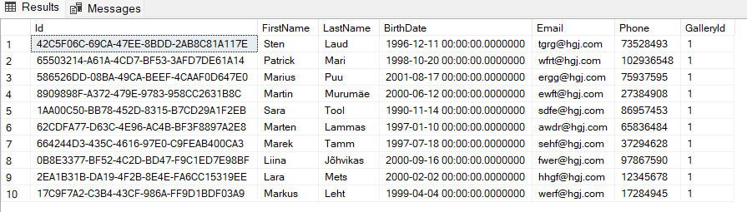

**Kolm JOIN päringut**

SELECT Artist.Id, Artist.FirstName, ArtOwner.Id, ArtOwner.FirstName

FROM dbo.Artist

LEFT OUTER JOIN dbo.ArtOwner

ON Artist.FirstName = ArtOwner.FirstName

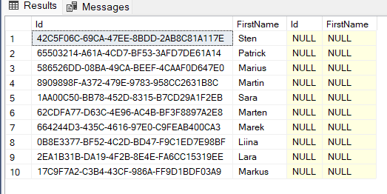

SELECT Artist.Id, Artist.FirstName, ArtOwner.Id, ArtOwner.FirstName

FROM dbo.Artist

FULL JOIN dbo.ArtOwner

ON Artist.FirstName = ArtOwner.FirstName

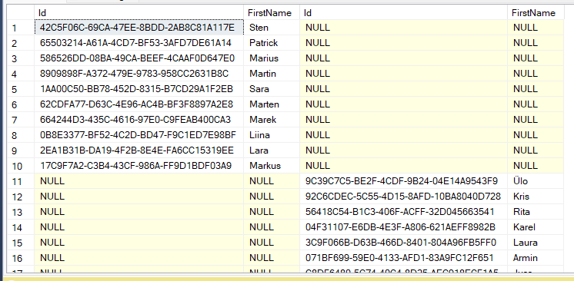

SELECT Artist.Id, Artist.FirstName, ArtOwner.Id, ArtOwner.FirstName

FROM dbo.Artist

RIGHT JOIN dbo.ArtOwner

ON Artist.FirstName = ArtOwner.FirstName

